**Class Diagrams**

After reviewing the Quiz Machine requirements and specification, there are 3 classes that were discovered. The 3 classes are:

**User:** The User would signify the current user of the Quiz Machine WebApp. The user is a generic class that does not have any information or attributes that would permit outside. Once the user has navigated away from the page then any scores or play time will be lost and these attributes are reset for the next.

**Quiz:** The Quiz class represents the current quiz that the user is currently taking. The quiz class should be able to retrieve 10 questions from the Question class at the specific level selected by the User to create the quiz.

**Attributes:**

Level: Signifies what level (I, II, III) was selected by the User.

Game Mode: Signifies if user checked the Sudden Death mode or not.

Score: Keeps the running score of the current Quiz being answered by the User.

Game Time: Keeps track of the time spent by the User taking the Quiz.

**Methods:**

Retrieve Questions: Retrieves Questions.

**Question:** The Question class represents 1 specific question on the topic of Ancient History. This question represents a multiple choice question. Attributes for this class would consist of the Level of the question, the question, answer and other possible answers. There is a relationship shown between Quiz and Question since a Quiz will contain 10 questions all at the same Question level.

**Attributes:**

Question Level: The level (I, II, III) of the question.

Question: String of the Question.

Answer: String answer to the Question .

Possible Answer1: Possible answer that will displayed as a choice when questions is displayed in multiple choice format.

Possible Answer2: Possible answer that will displayed as a choice when questions is displayed in multiple choice format.

Possible Answer3: Possible answer that will displayed as a choice when questions is displayed in multiple choice format.

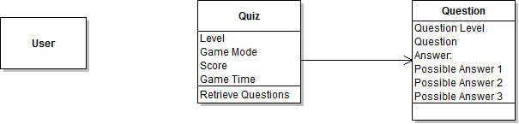

**Class Diagram 1:**

**Sequence Diagrams**

The sequence diagrams that are covered here would be:

1. User chooses to take a quiz at a selected level in normal mode

2. User chooses to take a quiz at a select level in Sudden Death Mode.

**Sequence Diagram 1:**

Brief Description:

The User will start at the Begin Quiz Page. The user has selected the quiz level they want to take but have not chosen the Sudden Death Mode. The score and time for the requested quiz level will be cleared and 10 questions at the specified level will be retrieved. The questions will then be displayed 1 at a time. After the user has selected and submitted their answer, the running score will be updated and then display the next question. After all 10 questions have been answered; the user will be taken to the results page where all 10 questions, the user’s answers and the correct answers will be displayed. The user can then choose to restart the level or continue to the next level to take another quiz.



Class Diagram 1:

Sequence Diagrams:

The sequence diagrams that are covered here would be 1. User chooses to take a quiz at a selected level in normal mode and 2. Use

Sequence Diagram 1:

Brief Description:

The User will start at the Begin Quiz Page. The user has selected the quiz level they want to take but have not chosen the Sudden Death Mode. The score and time for the requested quiz level will be cleared and 10 questions at the specified level will be retrieved. The questions will then be displayed 1 at a time. After the user has selected and submitted their answer, the running score will be updated and then display the next question. After all 10 questions have been answered; the user will be taken to the results page where all 10 questions, the user’s answers and the correct answers will be displayed. The user can then choose to restart the level or continue to the next level to take another quiz.



Class Diagram 1:

Sequence Diagrams:

The sequence diagrams that are covered here would be 1. User chooses to take a quiz at a selected level in normal mode and 2. Use

Sequence Diagram 1:

Brief Description:

The User will start at the Begin Quiz Page. The user has selected the quiz level they want to take but have not chosen the Sudden Death Mode. The score and time for the requested quiz level will be cleared and 10 questions at the specified level will be retrieved. The questions will then be displayed 1 at a time. After the user has selected and submitted their answer, the running score will be updated and then display the next question. After all 10 questions have been answered; the user will be taken to the results page where all 10 questions, the user’s answers and the correct answers will be displayed. The user can then choose to restart the level or continue to the next level to take another quiz.

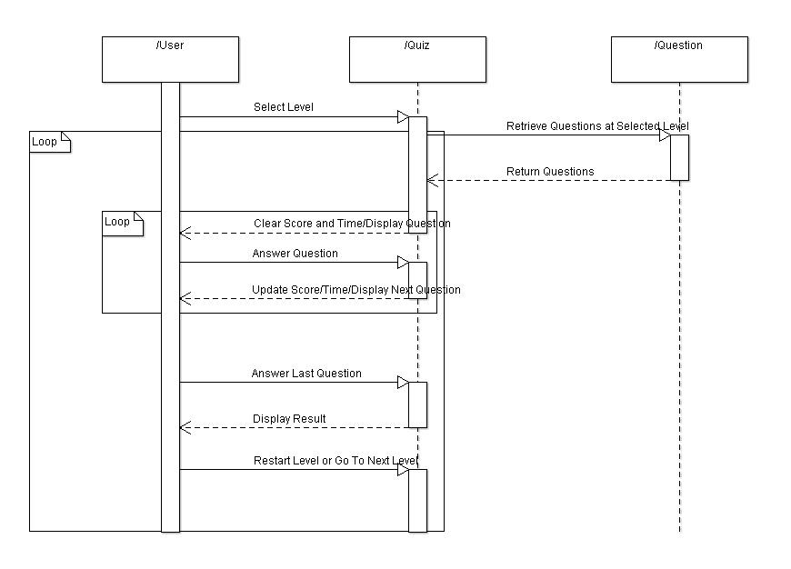

**Sequence Diagram 2:**

The User will start at the Begin Quiz Page. The user has selected the quiz level they want to take and has chosen the Sudden Death Mode. In Sudden Death mode the user has 3 chances and after 3 chances the user will be taken to the results page even though all 10 questions may not have yet been displayed.

The score and time for the requested quiz level will be cleared and 10 questions at the specified level will be retrieved. The questions will then be displayed 1 at a time. After the user has selected and submitted their answer, the running score will be updated. If the user has used up their 3 chances then they will be taken to the results page, otherwise, the user will continue to the next question. After all 10 questions have been answered; the user will be taken to the results page where all 10 questions, the user’s answers and the correct answers will be displayed. The user can then choose to restart the level or continue to the next level to take another quiz.

